**INTRODUCTION**

The necessity of optimization techniques arises to create more efficient processes in every field ,be it industrial , agricultural ,environmental or as general as tasks in daily life. Generally they are used to minimise certain entities which play critical role in determining the effectiveness of a task. These entities could be minimising the overall cost , time for completion of a process , etc. Sometimes the maximization problem needs to be dealt using these techniques such as maximization of overall profit , crop productivity in a field, etc.

These tasks may involve one variable or multiple variables. Depending upon the nature and number of variables in a problem certain methods or techniques are devised to find an optimal solution for the prescribed problem. These methods can be classified under two categories:

1. **Direct Search Methods:** These methods employ the algorithm to create an estimate of the interval in which the optimal point is supposed to be. These are methods such as Exhaustive Search, Bounding phase ,etc.
2. **Region Elimination Methods :** This category of methods devise the algorithm to give a more accurate interval location nearer to the optimum solution depending upon the termination and iteration counter created. These are methods such as Interval Halving , Fibonacci Search, Golden Section .

**Assumption:** In all the techniques we have an implicit assumption that in a specified interval there lies only one extreme / optimal value.

In this report we will be discussion about the employability of Bounding Phase and Golden search method to accurately bound an optimum value.

**BOUNDING PHASE METHOD**

In this method we create an estimated/rough interval from the specified interval in the problem where our extrema exists. First we choose an initial guess along with number of iterations to start the algorithm. From this value $∆$ is created .Depending upon these values and the value of functions calculated from two points which lies on either side of the function value at the initial guess. After this the sign of $∆$ is determined which dictates the direction of search algorithm. After that exponential function is used for the extrapolation of domain points till the extrema is bracketed. Following are the steps involved in algorithm:

**Step 1:** Take an initial guess ($x_{0}$) from the user and also increment value $∆$. Set k = 0.

**Step 2:** Find function value at $x_{0}$ and at two points at $∆$ distance on either side of $x_{0}$.

If, $f\left(x_{0}- ∆\right) ≥ f\left(x_{0}\right) ≥ f(x_{0} + ∆)$, then take the value of ∆ as positive value, else if $f\left(x_{0}- ∆\right) ≤ f\left(x_{0}\right) ≤ f(x_{0} + ∆)$, then take the value of ∆ as negative value, else ask for the another initial guess.

**Step 3:** Calculate $x^{(k+1)}= x^{(k)}+ 2^{k}* ∆$.

**Step 4:** If $f (x^{(k+1)}) < f (x^{(k)})$, then increase the k by 1 and go to step 3, else terminate the algorithm and our extreme point will lie in the interval $(x^{\left(k-1\right)}, x^{(k+1)})$.

The accuracy of the final interval depends on the $∆$ value as will be shown in the observation table later . If $∆$ value is large , bracketing is fast but accuracy is poor. On the other hand if it is small , bracketing is slow as more functions are to be evaluated but accuracy is better. This method is better than other direct search method as it employs the exponential extrapolation which brackets the extrema in less time.

**GOLDEN SECTION SEARCH METHOD**

In this method the search space is linearly mapped onto interval (0,1), after that , based on the golden number 0.618 , two points are chosen in the mapped interval and depending upon the value of mapped function at these points and the boundary points along with the termination criteria ,certain set of region is eliminated. Following are the steps involved in this algorithm:

**Step1:** Set the interval of x, that is, (a, b) and a small number ε.

**Normalize the variable.**

Normalize the variable x by using the equation ω = (x − a)/(b − a). Thus, aω = 0, bω = 1, and Lω =1. Set k = 1.Compute two new points.

**Step2:** Set ω1 = aω + (0.618) Lω and ω2 = bω − (0.618) Lω.Compute f(ω1) or f(ω2), depending on whichever of the two was not evaluated earlier.

Eliminate region.

Set new aω, bω and Lω = bω − aω. Termination condition.

**Step** **3:** Is | Lω |≤ ε small? If no, set k = k + 1, go to Step 2; Else Terminate.

The accuracy of final interval depends upon the termination value ε chosen at the starting of algorithm. Accordingly it terminates as per the desired accuracy with interval very close to optimal value.

**RESULT AND DISCUSSION**

In this part, the discussion on results obtained via program on the following questions has been made.

Maximize, $f_{1}= {(2x-5)}^{4}- {(x^{2}-1)}^{3}$, in interval (-10, 0)

Maximize, $f_{2}= 8 + x^{3} - 2x - {2e}^{x}$, in interval (-2, 1)

Maximize, $f_{3}= 4x(\sin{x})$, in the interval (0.5, π)

Minimize, $f_{4}= 2{(x-3)}^{3}- e^{0.5x^{2}}$, in the interval (-2, 3)

Minimize, $f_{5}= x^{2}- 10e^{0.1x}$, in the interval (-6, 6)

Maximize, $f_{6}= 20\sin{x}- 15x^{2}$, in the interval (-4, 4)

Result obtained after the bracketing via Bounding Phase method has been done.

|  |  |  |  |  |  |
| --- | --- | --- | --- | --- | --- |
| Initial Guess | Step Count | Delta | Iteration Count | Function evaluations | Interval after Bracketing |
| Q1. | | | | | |
| -7 | 80 | 0.125 | 4 | 8 | (-6.50, -5.00) |
| 110 | 0.090 | 5 | 9 | (-6.27, -4.09) |
| 180 | 0.055 | 5 | 9 | (-6.55, 5.22) |
| Q2. | | | | | |
| -0.8 | 80 | -0.037 | 3 | 7 | (-1.100, -0.875) |
| 110 | -0.027 | 3 | 7 | (-1.018, -0.855) |
| 180 | -0.016 | 4 | 8 | (-1.067, -0.867) |
| Q3. | | | | | |
| 1 | 80 | 0.033 | 6 | 10 | (1.528, 3.113) |
| 110 | 0.024 | 6 | 10 | (1.384, 2.537) |
| 180 | 0.014 | 7 | 11 | (1.470, 2.878) |
| Q4. | | | | | |
| 1.8 | 80 | 0.062 | 4 | 8 | (1.000, 1.750) |
| 110 | -0.045 | 3 | 7 | (1.436, 1.709) |
| 180 | -0.027 | 4 | 8 | (1.356, 1.68 9) |
| Q5. | | | | | |
| -3 | 80 | 0.150 | 5 | 9 | (-1.800, 1.800) |
| 110 | 0.109 | 6 | 10 | (-1.255, 3.982) |
| 180 | 0.066 | 7 | 11 | (-0.867, 5.533) |
| Q6. | | | | | |
| 2 | 80 | 0.100 | 5 | 9 | (-1.200, 1.200) |
| 110 | -0.072 | 5 | 9 | (-0.327, 1.418) |
| 180 | -0.044 | 6 | 10 | (-0.844, 1.289) |

Table Bracketing via Bounding Phase method

As discussed above , the accuracy obtained through bounding phase method depends upon the chosen $∆$ value. In the above observation table, initial guess is fixed and the value of $∆$ is changed by changing the value of n (step counts).

As evident from the table, n increases , corresponding iteration count and number of function evaluations also increases but range of the interval may increase or decrease as it also depends upon the choice of initial guess. If the initial point is nearer to the extreme value then on changing the step counts may not give the significant change in the interval value.

Table Golden Section Output with varying precision value

|  |  |  |  |
| --- | --- | --- | --- |
| Initial Value | Iteration Count | Function Evaluations | Extrema |
| Question No.1 | | | |
| 0.1 | 5 | 7 | -5.760 |
| 0.01 | 10 | 12 | -5.775 |
| 0.001 | 14 | 28 | -5.775 |
| Question No.2 | | | |
| 0.1 | 5 | 7 | -0.961 |
| 0.01 | 2 | 14 | -0.96 |
| 0.001 | 4 | 28 | -0.96 |
| Question No.3 | | | |
| 0.1 | 5 | 7 | 2.045 |
| 0.01 | 10 | 12 | 2.029 |
| 0.001 | 15 | 17 | 2.029 |
| Question No.4 | | | |
| 0.1 | 5 | 7 | 1.586 |
| 0.01 | 10 | 12 | 1.591 |
| 0.001 | 15 | 17 | 1.591 |
| Question No.5 | | | |
| 0.1 | 5 | 7 | 0.549 |
| 0.01 | 10 | 12 | 0.523 |
| 0.001 | 15 | 17 | 0.527 |
| Question No.6 | | | |
| 0.1 | 5 | 7 | 0.551 |
| 0.01 | 10 | 12 | 0.562 |
| 0.001 | 15 | 17 | 0.563 |

As evident from the table, with the decrease in the value of ε , corresponding iteration count and number of function evaluations also increases along with the improvement in the objective function. If the initial point is nearer to the extreme value then on changing the step counts may not give the significant change in the interval value.

Following graphs shows the variation of best Function values obtained in the algorithm for different initial guess points for Question 1.

**Bounding phase method:**

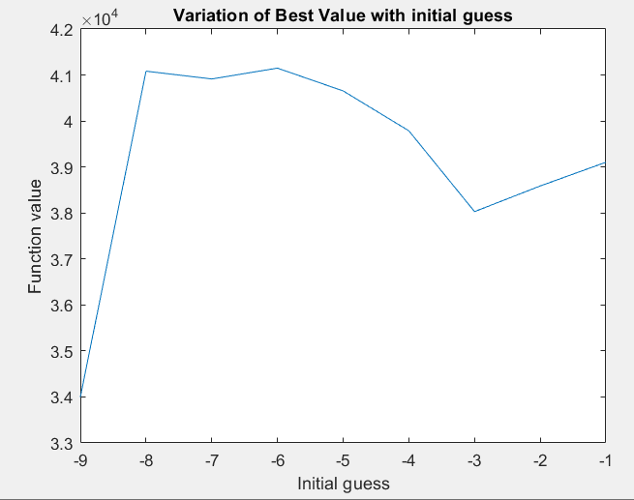

Graph Variation of best value with initial guesses by Bounding phase method

**Golden Section Search Method(with input interval from Bounding phase method):**

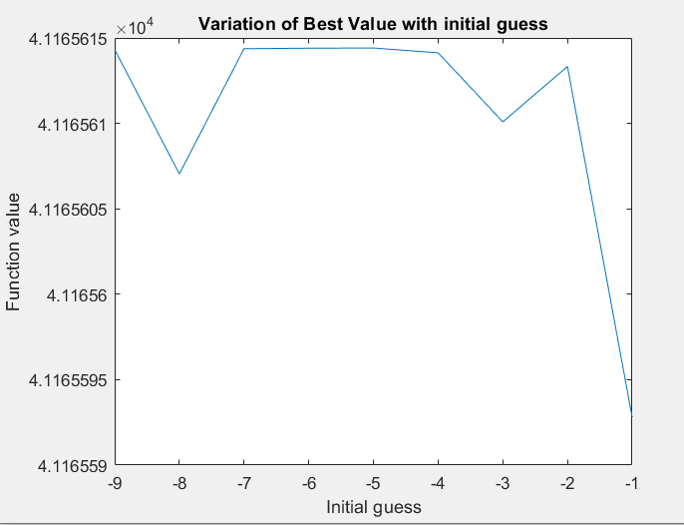

Graph Variation of best value with initial guesses by Golden selection search method

As discussed, it is evident from the above graphs that the improvement in the function values takes place significantly when the initial guess is away from the extreme value and very less changes occurs for the points taken nearer to the extrema.

Output Plots of Bounding phase and subsequent implementation of Golden Section with the interval obtained from Bounding phase:

**Question1.**

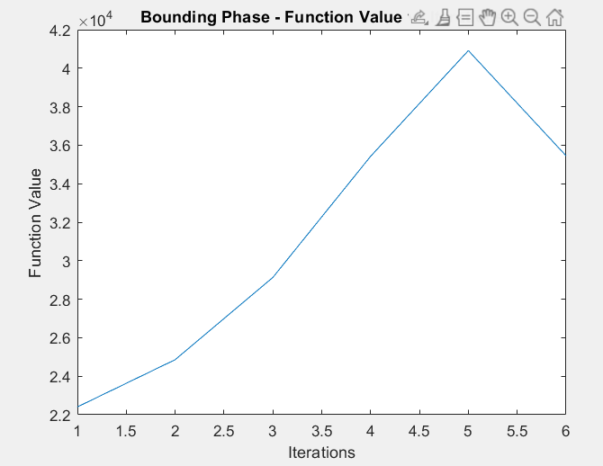

Graph Functional value by Binding Phase Method for question no.1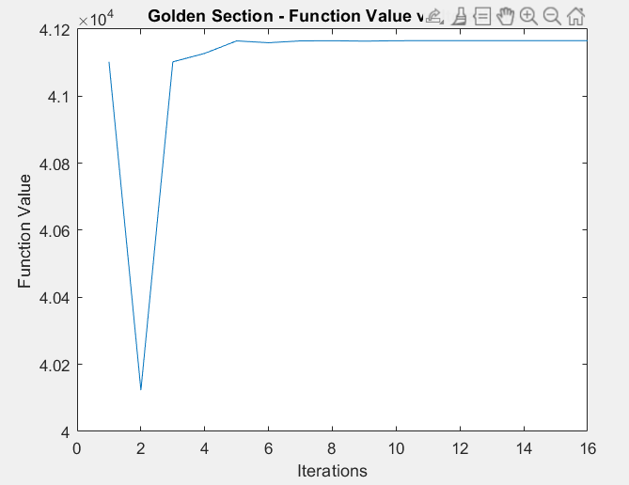

Graph Functional value by Golden selection Method for question no.1

**Question2.**

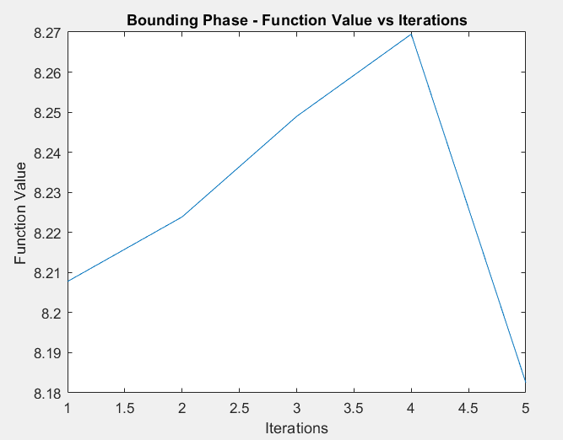

Graph Functional value by Binding Phase Method for question no.2

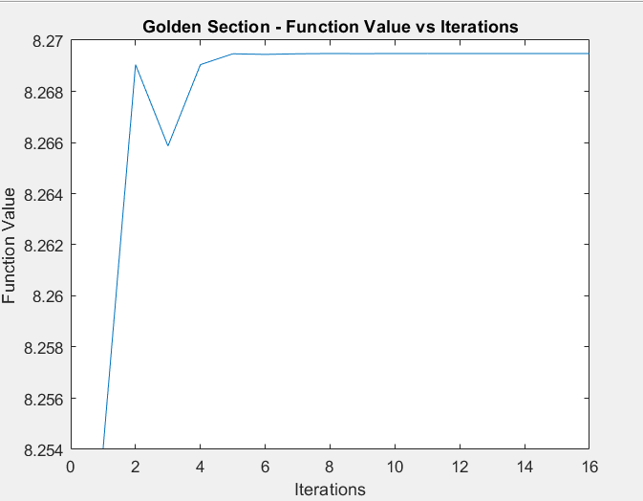

Graph Functional value by Golden selection Method for question no.2

**Question 3.**

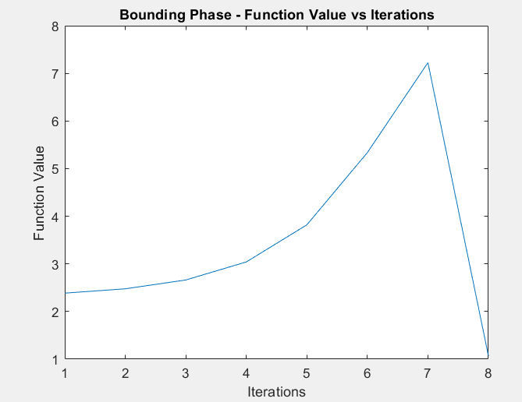

Graph Functional value by Binding Phase Method for question no.3

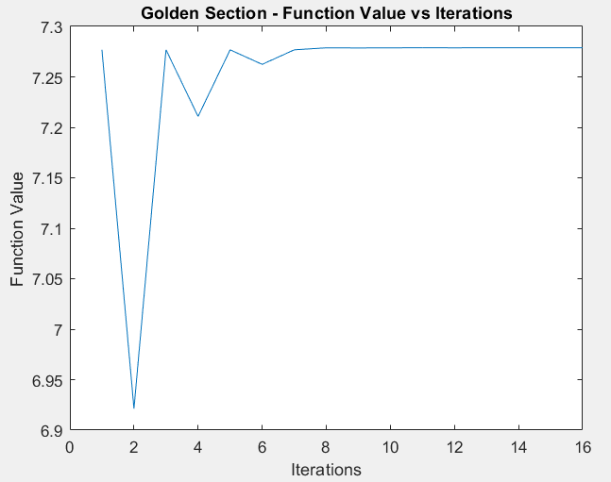

Graph Functional value by Golden section Method for question no.3

**Question 4**

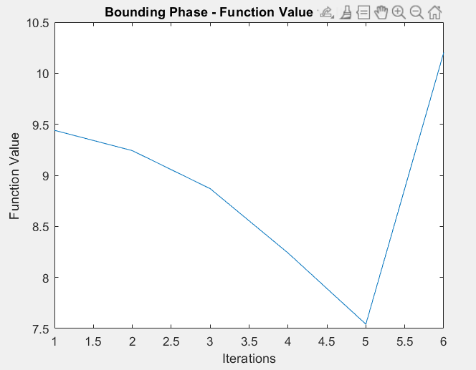

Graph Functional value by Binding Phase Method for question no.4

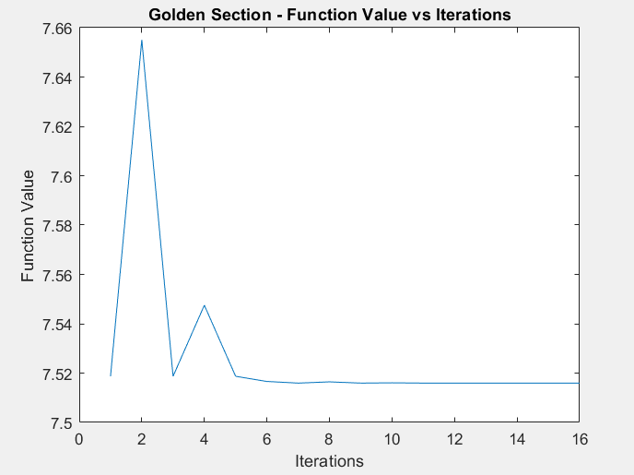

Graph Functional value by golden section Method for question no.4

**Question 5**

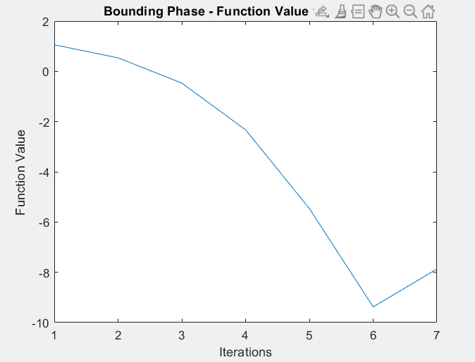

Graph Functional value by Binding Phase Method for question no.5

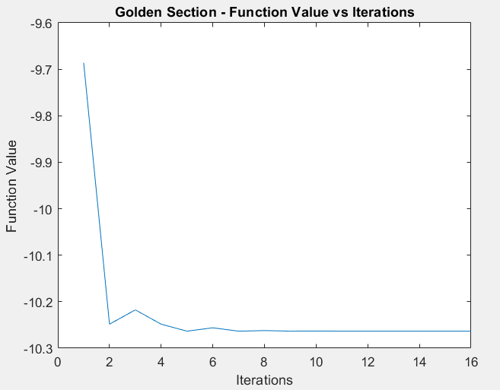

Graph Functional value by Golden Section Method for question no.5

**Question 6**

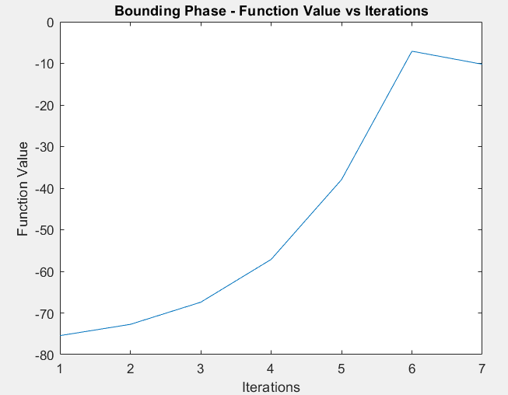

Graph Functional value by Binding Phase Method for question no.6

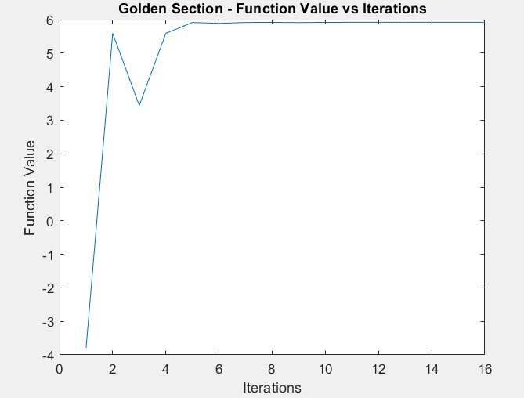

Graph Functional value by Golden section Method for question no.6

**COMBINED RESULT OF BOUNDING PHASE METHOD AND GOLDEN SECTION METHOD**

Important outcomes, when both methods are used by combining, are listed below:

* Bounding Phase method provides the rough interval with extrema in it.
* We use that interval as an input for Golden Section Search method
* Golden Section method able to locate extreme point within an interval as per the desired accuracy, given by the Bounding Phase method.

Below are the results of Final Brackets for each problem developed by each (Bounding Phase Method & Golden Section method) for a particular choice of input values i.e., Initial guess(X0) Step count(N) ,epsilon(ε) .

|  |  |  |  |  |  |
| --- | --- | --- | --- | --- | --- |
| Question | Bounding Phase | Golden Section | Input values | | |
| X0 | N | ε |
| 1.Max. $${(2x-5)}^{4}- {(x^{2}-1)}^{3}$$ In (-10,0) | (-6.467, -4.867) | -5.775 | -7 | 150 | 0.001 |
| 2.Max. $8 + x^{3} - 2x - {2e}^{x}$ in (-2,1) | (-1.120 ,-0.880) | -0.960 | -0.8 | 150 | 0.001 |
| 3.Max. $4x(\sin{x})$ In (0.5, π) | (2.018 , 2.070) | 2.029 | 2 | 150 | 0.001 |
| 4. Min. $2{(x-3)}^{3}- e^{0.5x^{2}}$ in (-2,3) | (1.267 , 2.067) | 1.591 | 1 | 150 | 0.001 |
| 5. Min. $$x^{2}- 10e^{0.1x}$$ In (-6,6) | (-1.720 , 2.120) | 0.527 | -3 | 150 | 0.001 |
| 6.Max. $$20\sin{x}- 15x^{2}$$ In (-4,4) | (-1.147 , 1.413) | 0.563 | -2 | 150 | 0.001 |